ASSSIGNMENT 5

S.Jaswanth Venkata Rahul

192425048

SLOT-D

PYTHON PROGRAMMING FOR Cyber Security

CSA0839

1.Write a program for Function to add two numbers.

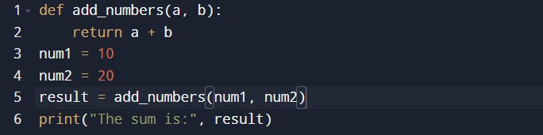

OUTPUT;-

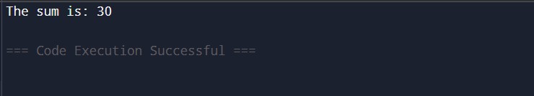

1. Write a program for Function to find factorial of a number

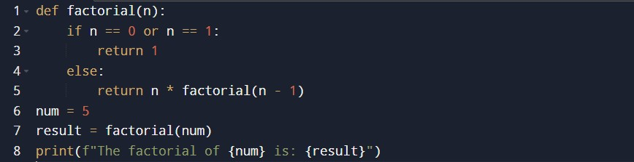

OUTPUT:-

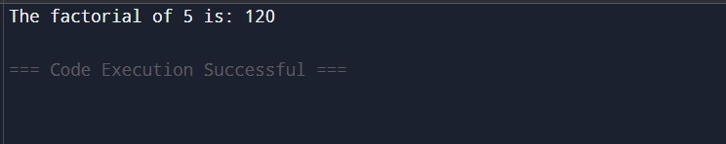

1. Write a program for Function to check even or odd.

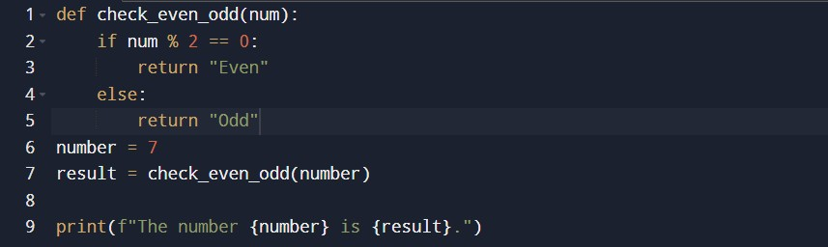

OUTPUT:-

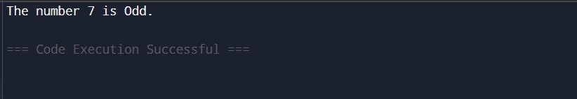

1. Write a program for Function to find power of a number

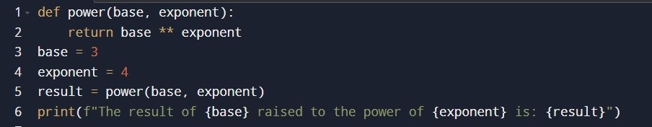

OUTPUT:-

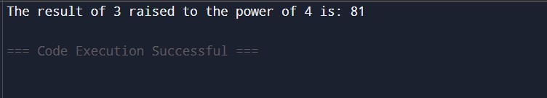

1. Write a program for Function to swap two numbers.

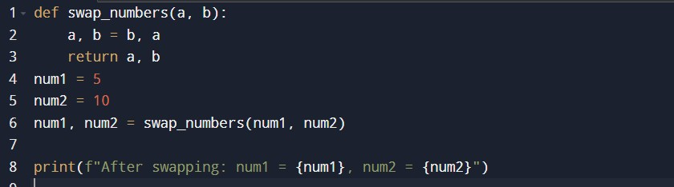

OUTPUT:-

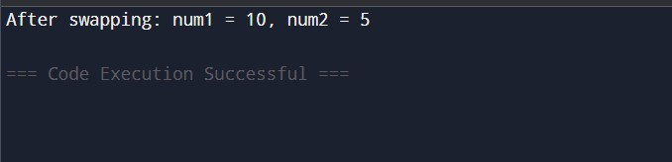

1. 1. len() - Get string length

#Python Program

#Simple string program using built in function text = &quot;Hello, #Python” print(len(text)) # Output: 14

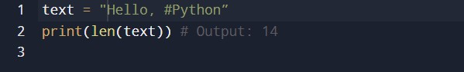

OUTPUT:-

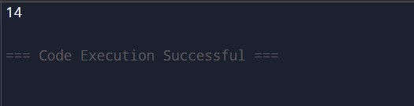

1. upper() - Convert to uppercase

#Python Program

#Simple string program using built in function text = &quot;hello&quot; print(text.upper()) # Output: HELLO

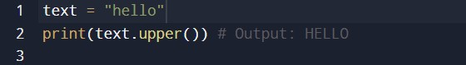

OUTPUT:-

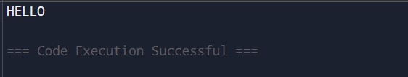

1. lower() - Convert to lowercase

#Python Program

#Simple string program using built in function text = &quot; #Python Program&quot; print(text.lower()) # Output: #Python Program

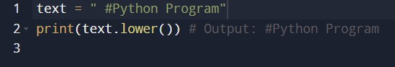

OUTPUT:-

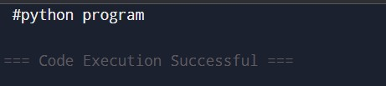

1. title() - Convert to title case

#Python Program

#Simple string program using built in function text = &quot;hello #Python Program&quot; print(text.title()) # Output: Hello #Python Program

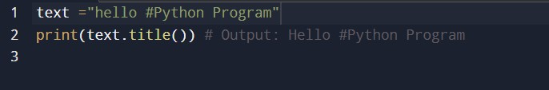

OUTPUT:-

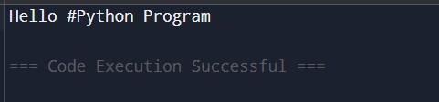

1. capitalize() - Capitalize first letter

#Python Program

#Simple string program using built in function text = &quot;hello #Python Program&quot; print(text.capitalize()) # Output: Hello #Python Program

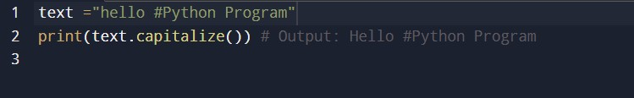

OUTPUT:-

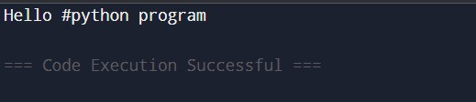

1. strip() - Remove leading and trailing spaces

#Python Program

#Simple string program using built in function text = &quot; &quot;

print(text.strip()) # Output: #Python Program

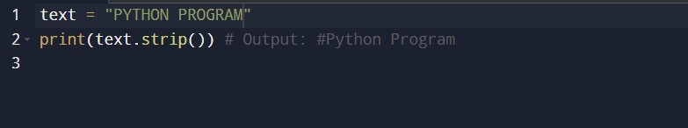

OUTPUT:-

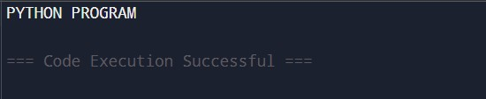

1. lstrip() - Remove leading spaces

#Python Program

#Simple string program using built in function text = &quot; Hello&quot; print(text.lstrip()) # Output: Hello

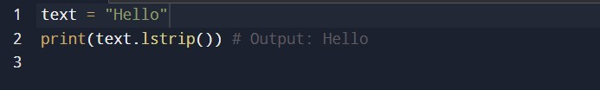

OUTPUT:-

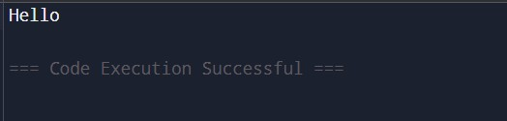

1. rstrip() - Remove trailing spaces

#Python Program

#Simple string program using built in function

text = &quot; &quot;

print(text.rstrip()) # Output: #Python Program

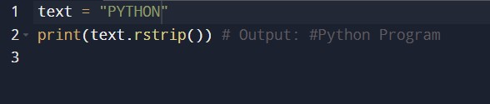

OUTPUT:-

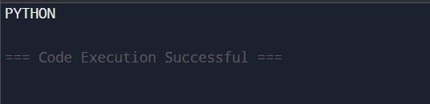

1. replace() - Replace substring

#Python Program

#Simple string program using built in function text = &quot;Hello, world!&quot; print(text.replace(&quot;world&quot;, &quot; #Python Program&quot;)) # Output: Hello, #Python Program!

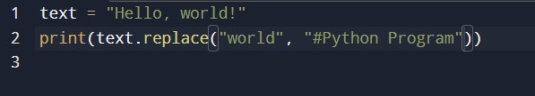

OUTPUT:-

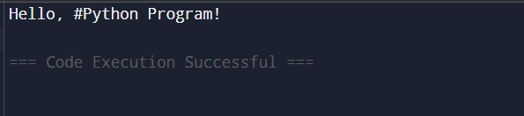

1. split() - Split string into list

#Python Program

#Simple string program using built in function text = &quot;apple,banana,orange&quot;

print(text.split(&quot;,&quot;)) # Output: [&#39;apple&#39;, &#39;banana&#39;, &#39;orange&#39;]

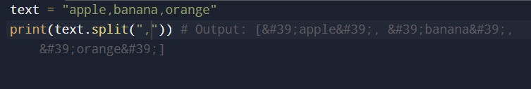

OUTPUT:-

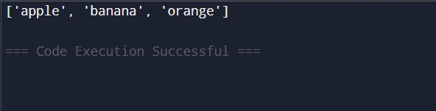

1. join() - Join list into string

#Python Program

#Simple string program using built in function

words = [&quot;Hello&quot;, &quot; #Python Program&quot;] print(&quot; &quot;.join(words)) # Output: Hello #Python Program

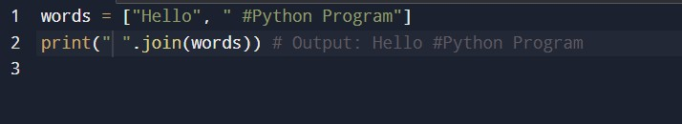

OUTPUT:-

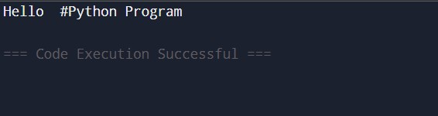

1. find() - Find substring index

#Python Program

#Simple string program using built in function text = &quot;programming&quot;

print(text.find(&quot;program&quot;)) # Output: 7

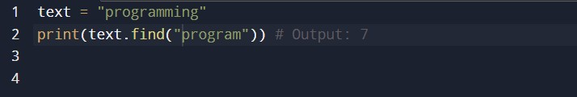

OUTPUT:-

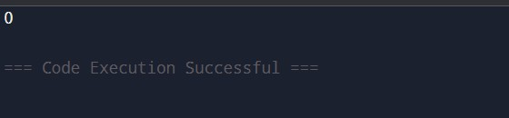

1. count() - Count occurrences of substring

#Python Program

#Simple string program using built in function text = &quot;banana banana&quot;

print(text.count(&quot;banana&quot;)) # Output: 2

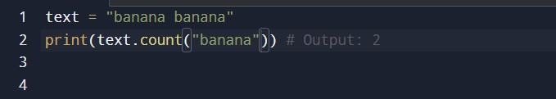

OUTPUT:-

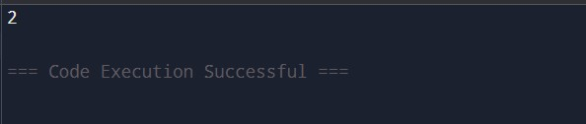

1. startswith() - Check if string starts with substring

#Python Program

#Simple string program using built in function text = &quot;Hello, #Python Program!&quot; print(text.startswith(&quot;Hello&quot;)) # Output: True

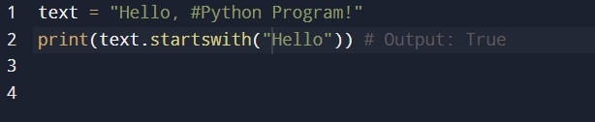

OUTPUT:-

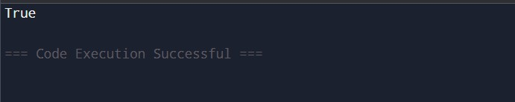

1. endswith() - Check if string ends with substring

#Python Program

#Simple string program using built in function text = &quot;is fun!&quot;

print(text.endswith(&quot;fun!&quot;)) # Output: True

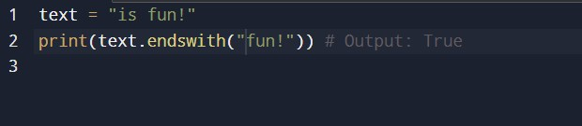

OUTPUT:-

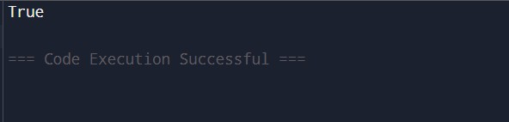

1. isalpha() - Check if all characters are alphabets

#Python Program

#Simple string program using built in function text = &quot;Hello&quot; print(text.isalpha()) # Output: True

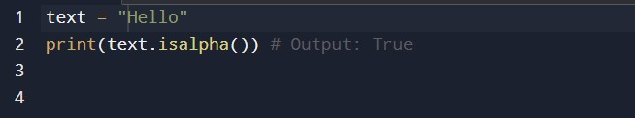

OUTPUT:-

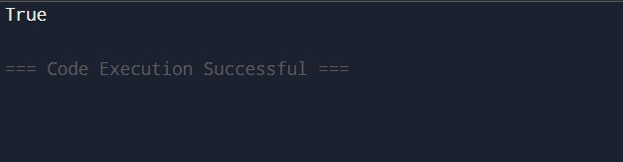

1. isdigit() - Check if all characters are digits #Python Program

#Simple string program using built in function num = &quot;12345&quot; print(num.isdigit()) # Output: True

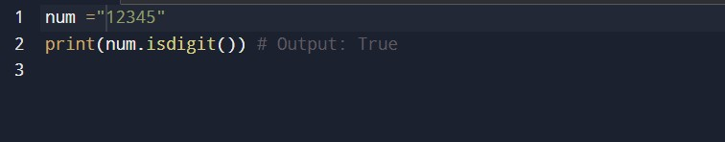

OUTPUT:-

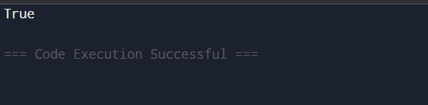

1. isalnum() - Check if string is alphanumeric #Python Program

#Simple string program using built in function

text = &quot;Hello123&quot;print(text.isalnum()) # Output: True

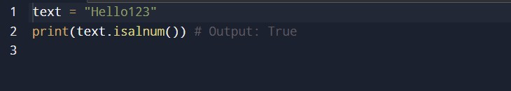

OUTPUT:-

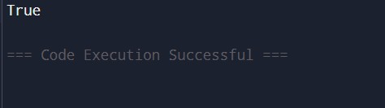

1. swapcase() - Swap case of characters

#Python Program

#Simple string program using built in function text = &quot;Hello #Python Program&quot; print(text.swapcase()) # Output: hELLO #Python Program

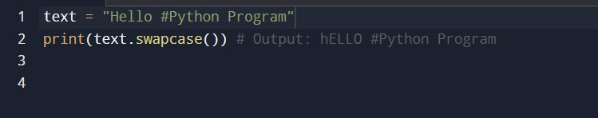

OUTPUT:-

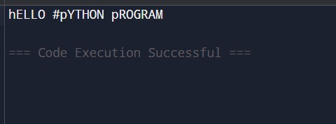

1. zfill() - Pad string with zeros

#Python Program

#Simple string program using built in function

text = &quot;42&quot; print(text.zfill(5)) # Output: 00042

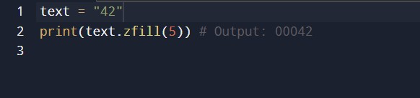

OUTPUT:-

